DELIVERY FORM

Please Read
For completing this form digitally:
- Open this document in Word, Google docs, Adobe or another source
- Complete this document digitally;
If you have more than one artwork complete the artwork information on page 3 for each artwork
- Save this document
You must save the doc as .doc or .pdf – do not save as Apple pages or Notepad.
- Email this document back to swaotearoa@gmail.com
For completing this form by hand:
- Print this document
(if you have more than one artwork print page 3 once for each artwork)
- Complete this document neatly by hand
- Include this documentation with your packaged artwork
- YOU THEN MUST EMAIL the following per each artwork to swaotearoa@gmail.com
Please don’t make me type up your artist statement by hand
- Name (or write anonymous):
- Title:
- Date made:
- Medium:
- Size:
- Price (or write Not For Sale):
- Statement:

The Due Date for artwork(s) is May 12th by 5pm. Drop off or Post your artworks to either:
NZPC Auckland – Unit 3/2 Canada St, Auckland
NZPC Wellington – Level 4, 204 Willis St, Wellington
*Please make sure your work is well wrapped and protected. Damage can occur even with couriers, so wrap your work well. We recommend you use track and trace so your work doesn’t get lost. Even if you are delivering your artwork yourself it needs proper wrapping!! We will not be responsible for poorly wrapped artworks!!
**If you need help with postage please contact us

The Artist Contact Details
(if printed tick the boxes, if completing digitally TYPE “YES” to accept the T&Cs)
Work Name:
Email:
Mobile:
Please tick (or type YES) to the following if you agree to –
- I grant the organisers of the SEX WORKERS OF AOTEAROA art exhibition permission to photograph and publish images of my artwork for promotional purposes.
- I accept full responsibility to any damage, loss or theft of my artwork during delivery/postage. All care will be taken in handling the artworks during the exhibition.
- I am responsible for the delivery and return fee (if not sold) to have my artwork delivered back to me. (Artworks will be returned to Auckland & Wellington NZPCs post exhibition).
- I am responsible for my artwork being ready to hang and/or ready to stand alone, or for the arrangement with Jordan for a plinth.
- I acknowledge that the organisers have no power over whether an artwork is successfully sold or not.
- I am 18 years or older.

Signed:

Artwork details
** If you are submitting only ONE artwork you only need to complete this page (page 3) once. If you are submitting more than one artwork, complete these details separately for each artwork.

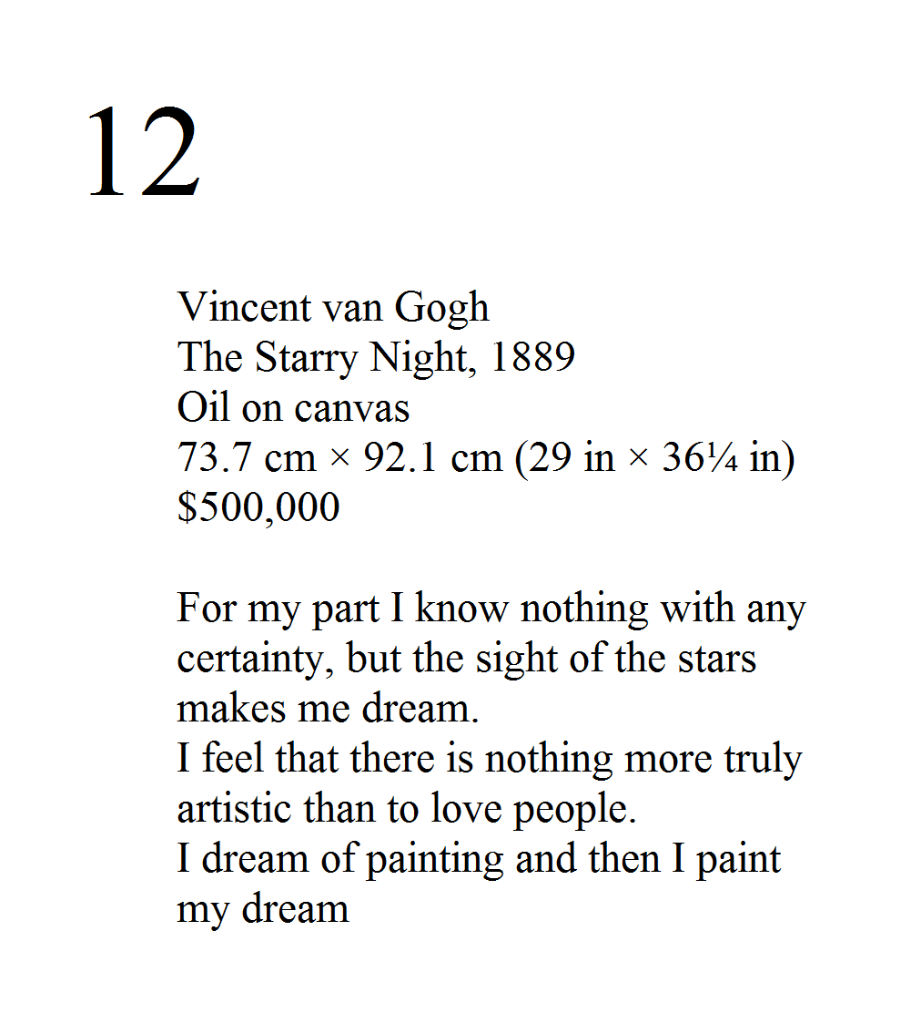
Your artwork details are what will be printed on the label next to your artwork, so visitors can read about the artist and the work.

Each label will have a:
- number
- your name (or artist name or write anonymous)
- artwork title
- date made
- medium
- size
- price
- artist statement (please write approximately 150-200 words. One sentence is not enough).
___________________________________________________________________________
Name (or artist name or write anonymous):
Title:
Date made:
Medium:
Size:
Price (or write Not For Sale):
Remember to include the 25% commission fee
Statement:

Checklist
- Ensure artwork(s) are ready to securely hang – have you read the HANGING DOC?
- If your artwork is a sculpture or needs a plinth, please ensure you have arranged with Jordan to be assigned a plinth.
- If your artwork requires AV, tech equipment or power supply please be in contact with Jordan.
- Include hanging instructions: if your work is multiple smaller works, please draw a diagram of how you want the works displayed e.g. in a grid, horizontally or vertically etc.
- If your artwork is a performance, song, poetry have you contacted Jordan to perform on opening night?
- Fill in pages 1-3 above (including extra page 3’s for more than one artwork).
- Have you spellchecked your artist statements (150-200 words is about right. Please do not write just one sentence).
- If you’ve printed this document, make sure its completed correctly and included in the package for delivery with your artworks.
- If you’ve printed this document remember you must email your artist info and statement on page 3 to swaotearoa@gmail.com
- Ensure your artwork(s) are securely packaged for delivery. The more bubble wrap the safer your artwork will be.
- Remember to label the outside of your packaged artwork with name and title
- If posting; Ensure the correct postal address has been written, and the package can be tracked.

Unsold works: return shipment of unsold works must be arranged by the artist within TWO MONTHS of the end of the exhibition (June 26th). Failure to arrange return delivery will result in the works becoming property of SWoA & likely being donated to NZPC.

CONGRATULATIONS! YOU DID IT!
We look forward to seeing you on opening night on June 11th!
(Don’t forget to RSVP for opening night)
Each artist will be receiving a commemorative catalogue of the exhibition on opening night, if you cannot make opening night, no worries, the catalogue will be posted to you.

